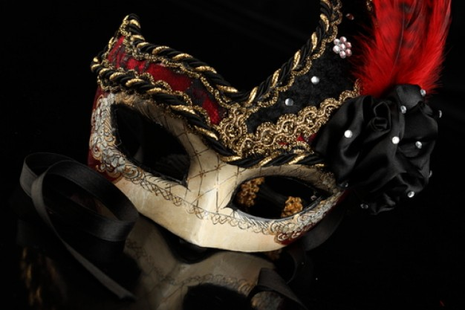

**Sponsored By: The Macintosh Corporation™  **

**Young Aces Masqeraders Band**

**Marching from Vlissengen Road to Lamaha Street.**

**Offers in five different sections**

**With prices ranging from 160, 220,280,350,425 respectively**

**$150 for food, drinks, bathroom facilities and bottled water**

**$50 for bathroom facilities and bottled water only**

**Tel: 639-7001**

**Email: www.yamb.band.com**

**Date: 1st November 2013**

**Time: 12:45 hours**